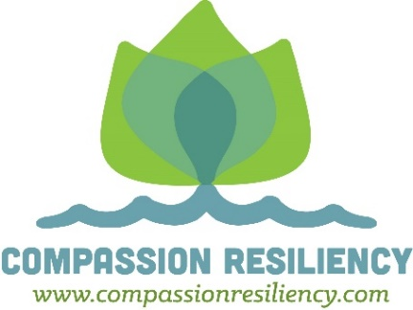

**EFFECTIVE ORGANIZATIONAL & INDIVIDUAL STRATEGIES FOR ADDRESSING COMPASSION FATIGUE/VICARIOUS TRAUMA**

1. Offering monthly peer support groups. (Balint Groups)
2. Employee Assistance Program and on-going encouragement to use EAP.
3. Providing on-going compassion fatigue and trauma training (retreats, book study groups, etc.)
4. Compassion fatigue prevention and developing healthy self care skills introduced at new staff orientation.
5. Realistic expectations about trauma work shared with applicants and the new applicant’s level of resiliency assessed. (Duty to Warn)
6. Employees develop self-care plans and support systems to prepare for and reduce the negative effects of trauma exposure. (WRAP)
7. Creating a culture that acknowledges and normalizes the effects of working with trauma survivors.
8. Adopting policies that promote and support staff self-care (Green Cross Academy of Traumatology Standards of Self Care Guidelines).
9. Allowing for diversified workloads (limiting trauma), reducing or balancing caseloads.
10. Ensuring a safe, private work environment.
11. Ensuring effective supervision (supervisors trained to promote staff self care and contribute to the organizational culture of safety and wellness).
12. Allowing work time for volunteering.
13. Supporting and modeling of self-care by management and administration (1:1's address self-care/compassion fatigue).
14. Supporting the use of low impact debriefing in the workplace.
15. Encouragement of positive peer interactions/social networks.
16. Annual completion of a Trauma Informed Care Organizational Assessment
17. Allowing flexible work schedules.
18. Allow two, 15 minute breaks per 8 hours.
19. Purchasing/implementing Heart Math.
20. Revising communication policy to foster direct communication between staff.
21. Staff appreciation (celebrations/retreat/recognition).
22. Support for attending off site trainings/professional development.
23. Establish Wellness Committee – incentivize good health

* Discount gym membership
* Offer fresh fruit/healthy food/beverages
* Yoga/exercise classes on site
* Gym equipment on site
* Employee fitness/nutrition programs
* Flu shots, blood pressure checks, health screens, etc.
* Chair massages offered on site
* On-going Lunch ‘N Learn Topics
* Staff self-care kits
* Daily Walk Groups at 10 am and 3 pm
* Fitbit competitions
* Aroma therapy
* Mindfulness/meditation breaks

1. On-going Staff Group Study with Compassion Fatigue Workbook.
2. Create an Affirmation Wall.
3. Create a mobile spa on wheels.
4. Define use of technology outside of office hours
5. Compassion Fatigue protection strategies addressed in organization newsletter (Safety John).
6. Plant a common garden area.
7. Access to different desks and chairs in the office (fitness ball, standing desks, etc.).
8. Create a “Comfort Room” for staff and consumers/patients.
9. Encourage use of vacation time (supervisor’s role model this).

**EFFECTIVE INDIVIDUAL STRATEGIES THAT WORK FOR REDUCING COMPASSION FATIGUE/VICARIOUS TRAINING AND INCREASING RESILIENCE**

1. Low impact debriefing.
2. Establish healthy boundaries.
3. Positive self-talk. 3-to-1 ratio of positive to negative emotions.
4. Transform the stress inherent in compassion fatigue/vicarious trauma.
5. Adequate sleep (7-8 hours).
6. 30 minutes of daily exercise.
7. Awareness of compassion fatigue/vicarious trauma signs and symptoms.
8. Grounding practices (mindfulness, meditation, yoga, chair yoga at office, etc.).
9. Positive peer supports (not gossiping, complaining, cynicism). Having a best friend at work (Gallup)
10. Part time work.
11. Take vacation time.
12. Reduced exposure to trauma.
13. Daily self-care.
14. Positive thinking about stress.
15. Practice gratitude (journal).
16. Body scan, breaks during the day.
17. Take the Professional Quality of Life Survey.
18. Savor life in the moment or in anticipation of positive future events.
19. Visit the Doctor and Dentist once a year.
20. Volunteer.
21. Learn something new or interesting every day. Be curious.
22. Practice kindness. 2/18kg